05 · User Flow
Project: StaffSync — HRM System Document type: Story
Status: To Do · Owner: Shiwani Jha

1. Purpose
The User Flow Diagram illustrates how the different types of users (HR, Manager and Employee) interact with the HRM system, from login to completing their tasks. It shows the sequence of actions in the application so that navigation is smooth and logical for every role.

2. Master User Flow
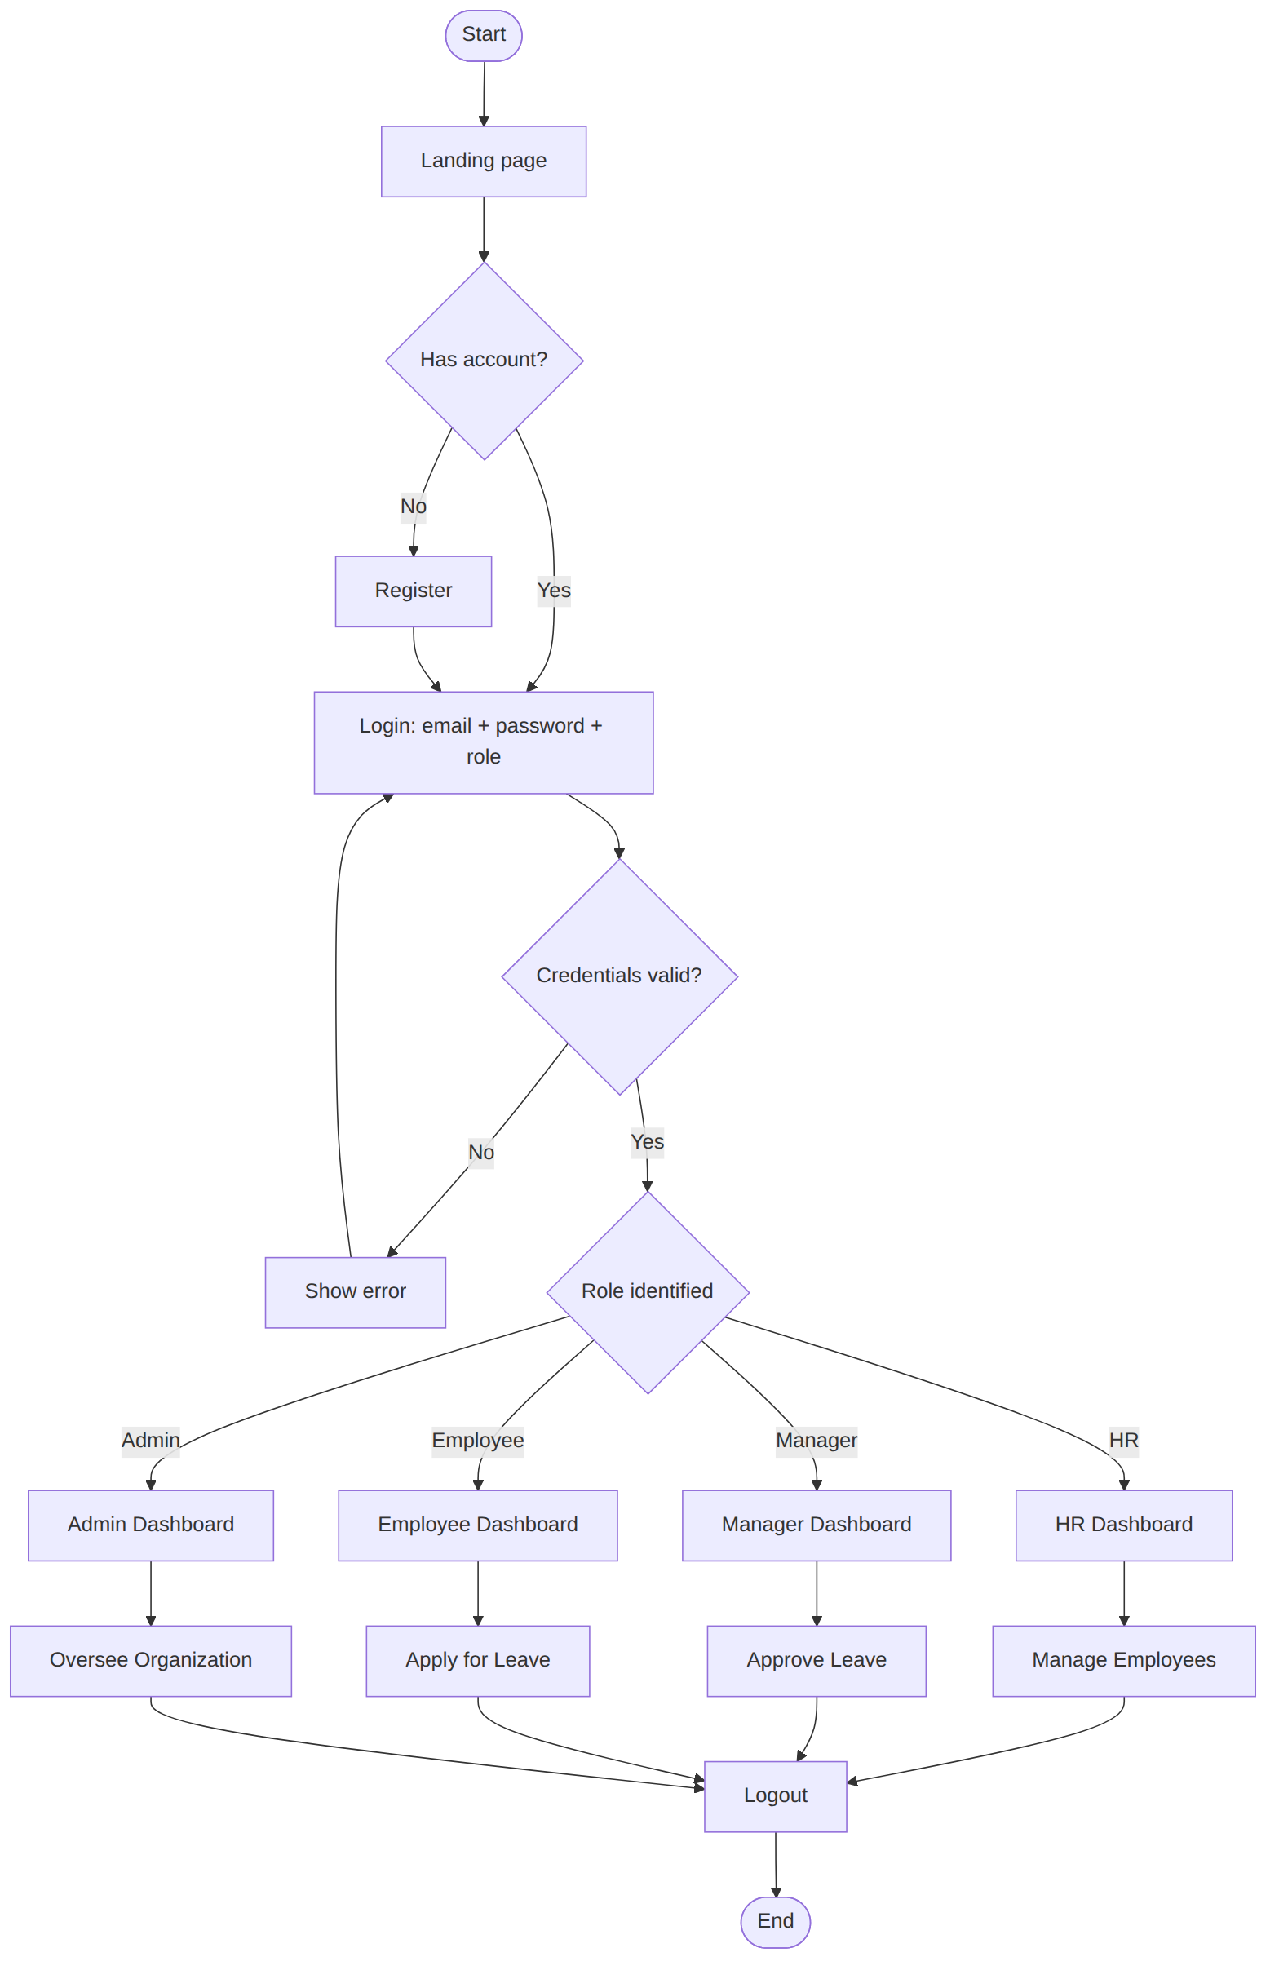

3. Stage-by-Stage Description

3.1 Start & Login
- The process begins when a user opens the application.
- Visitors without an account register. New public accounts default to Employee.
- Each user logs in with credentials and selects their role. The role must match the one assigned to the account.

3.2 Role Identification
Based on login credentials, the system identifies the user’s role and redirects them to the matching workspace: HR Dashboard, Manager Dashboard, Employee Dashboard or Admin Dashboard. The sidebar shows only the menu items allowed for that role.

3.3 End
After completing their tasks, users sign out. The token and cached user are cleared and the session ends.

4. Authentication Flows

4.1 Registration
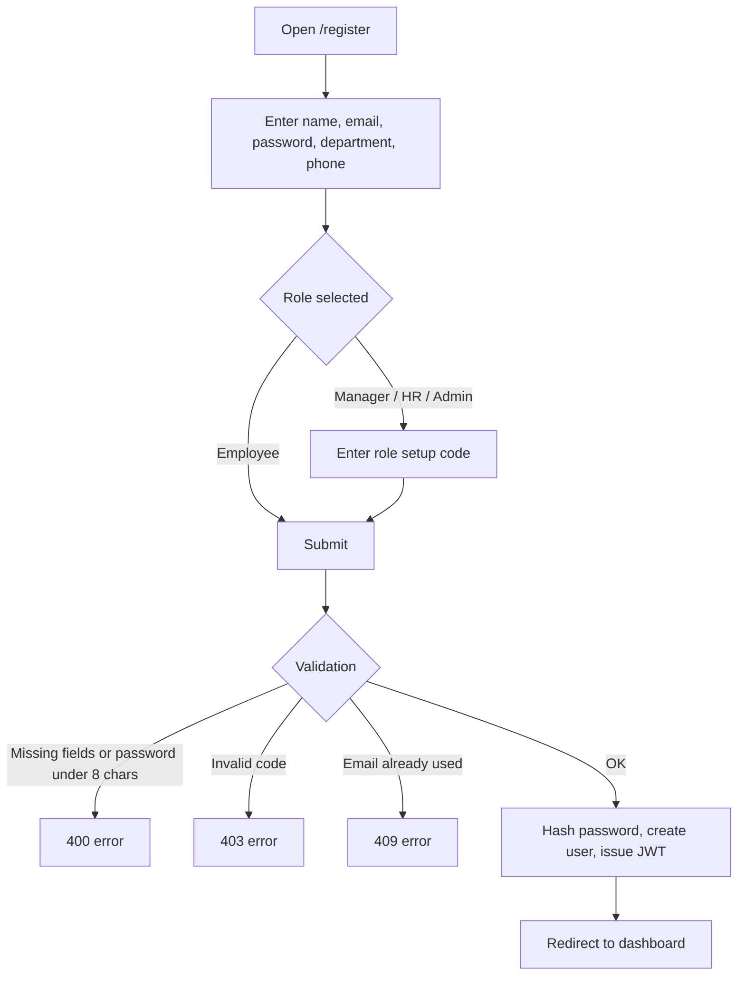

4.2 Login and session restore
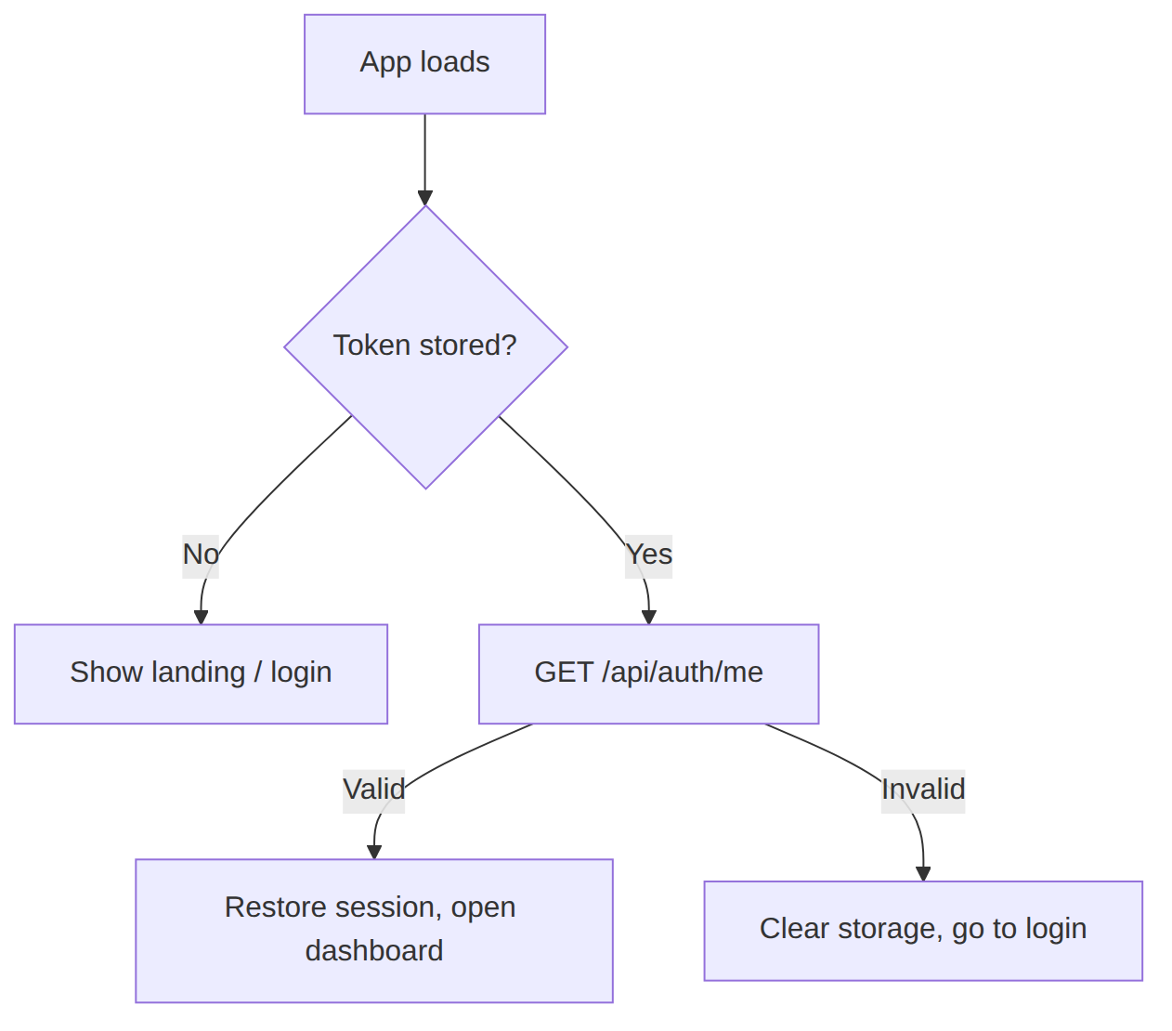

5. Role Flows

5.1 HR Flow
The HR user opens the dashboard to manage employee data, view attendance, approve or reject leave requests and post announcements. This gives centralized control over organizational activities.
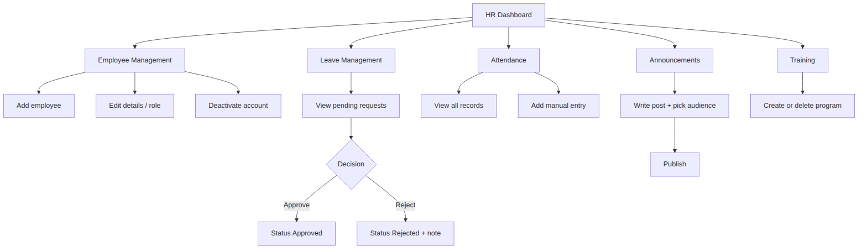

5.2 Manager Flow
The Manager views leave applications submitted by employees, approves or rejects them, and manages training and development schedules for the team.
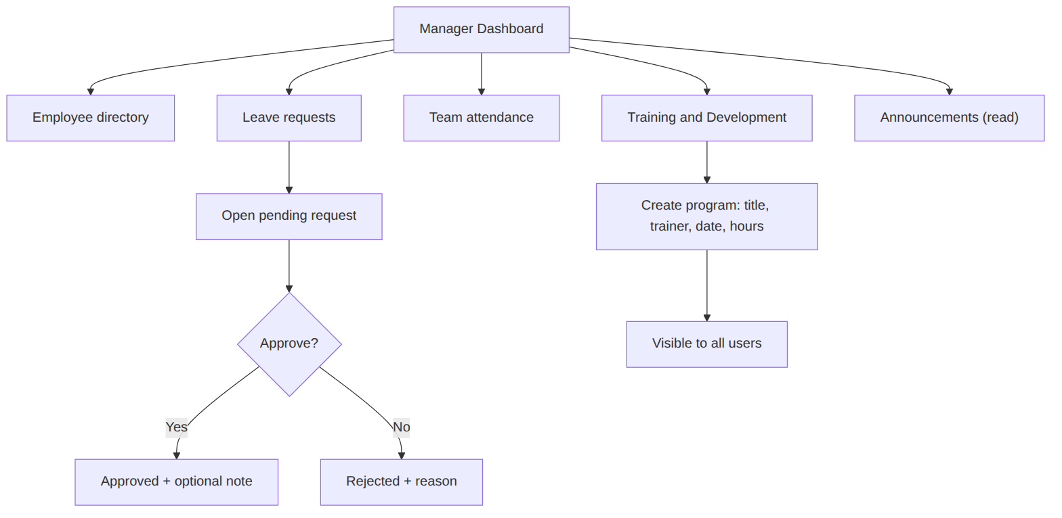

5.3 Employee Flow
The Employee applies for leave, views attendance records, and stays updated with announcements and company news.
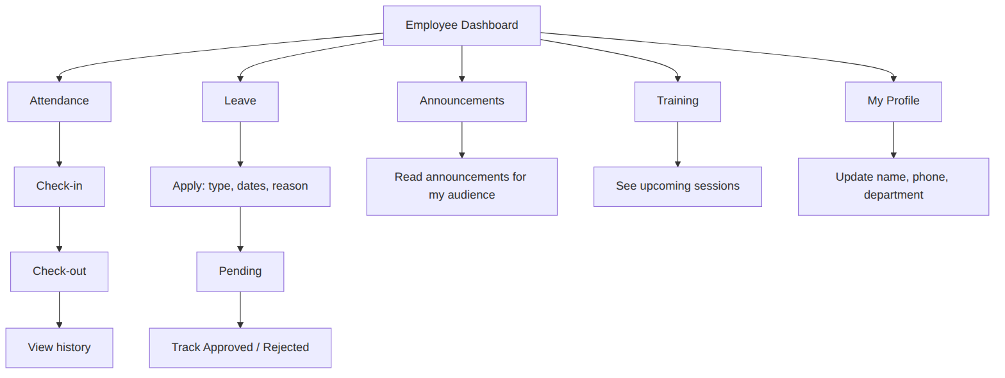

6. End-to-End Leave Sequence
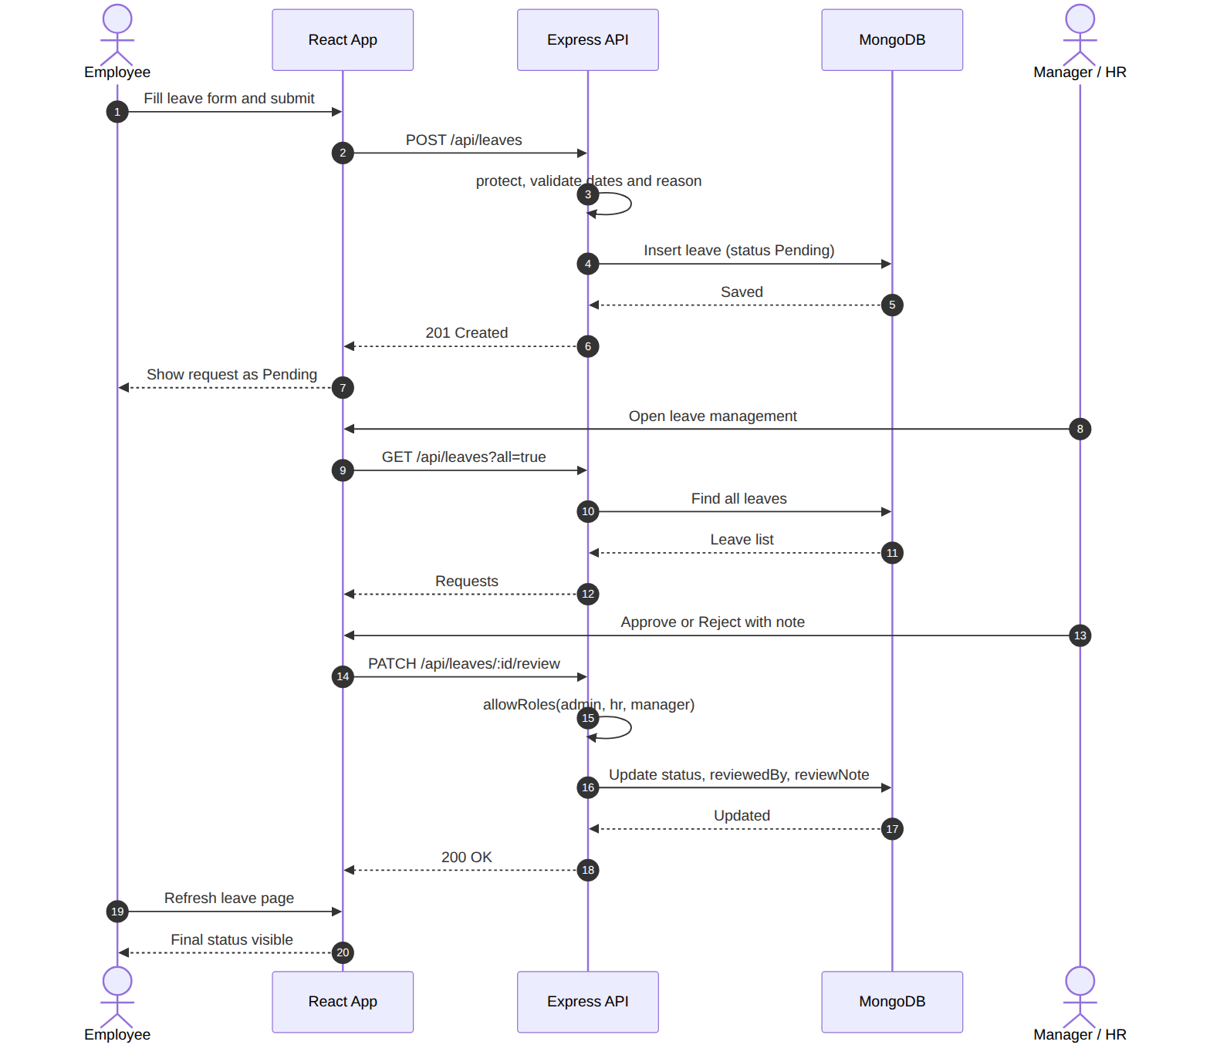

7. Daily Attendance Sequence
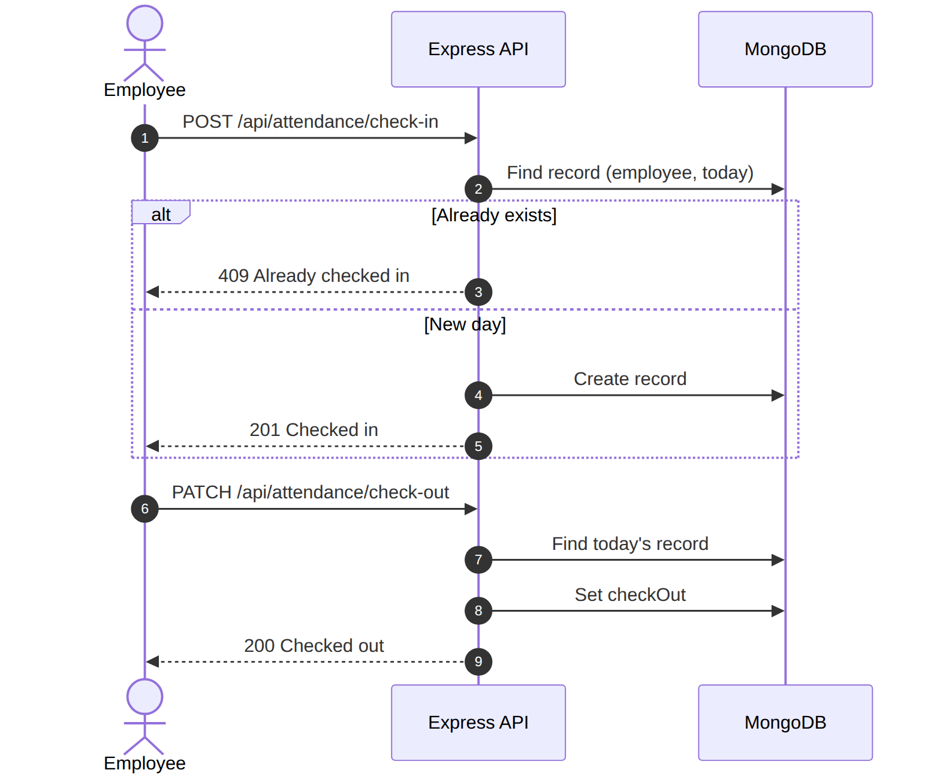

8. Navigation Map
Menu item | Route | Employee | Manager | HR | Admin
Dashboard | / | ✔ | ✔ | ✔ | ✔
Employees / Employee Management | /employees |  | ✔ | ✔ | ✔
Attendance | /attendance | ✔ | ✔ | ✔ | ✔
Leave management | /leaves | ✔ | ✔ | ✔ | ✔
Announcements | /announcements | ✔ | ✔ | ✔ | ✔
Training | /trainings | ✔ | ✔ | ✔ | ✔
My profile | /profile | ✔ | ✔ | ✔ | ✔

